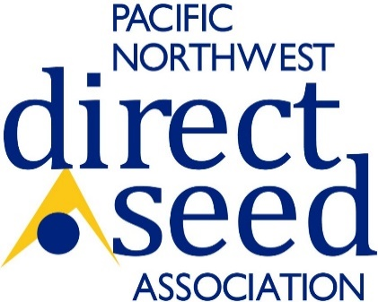
Do you have research that is relevant to our industry?
The PNDSA is in the process of planning our 2025 Cropping Systems Conference, January 7-8th in Kennewick WA.
We are extending an invitation for you to share research, education and outreach related to Direct Seed and Soil Health practices by calling for research and industry to submit potential presentations for the Cropping Systems Program.
Due to the time it takes to plan our meeting program, the due date for presentations will be June 3rd, 2024. Submissions will be reviewed by the Cropping Systems Planning Committee. If your research presentation is chosen you will be contacted by June 30, 2024.

Topic Title: ____________________________________________________________________

Soil Health
Intercropping
Cover Crops/Livestock
Economics
Pests, Diseases, Disorders, Nutrition
Weather
Alternative Crops
Technology
Other
Category:

Name of primary contact/author: ____________________________________
Primary contact email: _________________________
Abstract (no more than 200 words)
*Please submit separate applications for each intended presentation. pndsa@directseed.org

